

# **Paylink Important Concepts and Integration with SR5 CoinMech**

Table of Contents

**1. Introduction** 2

**1.1 Paylink Hardware Explaination** 2

**1.2 Paylink Device LED Status Indications** 3

**1.3 Hardware Installation** 3

**2. Using PayLink** 5

**2.1 How to get it working?** 5

**2.2 How to integrate with custom project?** 5

**2.3 How to connect Switch** 6

**2.3 SR5 Coin acceptor?** 6

**2.4 How to Test everything is working correctly?** 7

**3. Useful resources** 7

**If This documentaion and Project helps you or you liked it then feel free to send me your feedback. You can also contact me at** [**itc1232@gmail.com**](mailto:itc1232@gmail.com) **for any issue. Don’t forget to rate this project.**

# **1. Introduction**

I will not explain all things in details but I will define major things involved in coinMech Integration

## **1.1 Paylink Hardware Explaination**

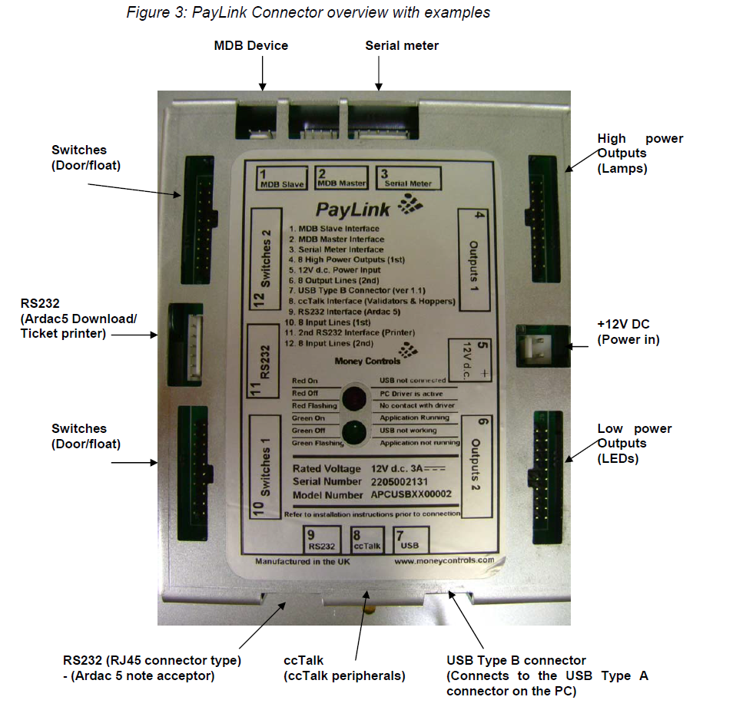

The above figure is showing the Paylink connections. Before Proceeding further please clearly understand the Paylink Device options available.

## **1.2 Paylink Device LED Status Indications**

|  |  |
| --- | --- |
| **RED** on | USB not connected (electrical) |
| **RED** off | PC driver is active |
| **GREEN** off | USB not working |
| **RED** flashing | No contact with PC driver program |
| **GREEN** flashing | Application not running |
| **GREEN** on | Application running & Peripherals |

## **1.3 Hardware Installation**

It is very easy to install the CCTALK with coin mech, coin acceptor and with despenser.

|  |  |
| --- | --- |
| Connect the ccTalk multi drop cable to **PayLink** | Connect the SR5 cable to the ccTalk multidrop cable and SR5. |
|  |
| Connect the 4 X 20-way headers to the I/O connectors | Connect **PayLink** to the 2-pin power cable and to a +12V dc power supply. The status LED  will show **RED ON** |
| Connect the USB cable to **PayLink** and to the PC. | |

# **2. Using PayLink**

You can download all of the Distribution files from following link and copy all files in the C:/ drive . <http://www.cranepi.com/en/products/view/147/tab:support#tabs> or check my uploaded files with this documentation

## **2.1 How to get it working?**

1. Copy Files to the JAVA Home/ bin
   1. 
   2. 
   3. 
   4. 
   5. 
2. Copy Driver file  to C:\Windows\System32\drivers
3. **AESWDriver.exe** (the PayLink driver, you always need to keep it running before doing anything)
4. **Firmware.exe (**upgrade program to latest firmware)
5. **Demo.exe** (Run test program and check that the device is working)

## **2.2 How to integrate with custom project?**

From download resources page you will find one tester program in Java as well. There is small piece of code that gives you an idea that how you can play with API. The AesImehei.jar (C:\PayLink Distribution\SDK\Java) library will give you an access to the API. So you create a new project and add that file into the project library that we will use later on.

## **2.3 How to connect Switch**

There are 20 places available on the PAYLINK Board to connect switch. It is the actual switches indexes are starting from 0 - 7 and 8-15 (Bottom to top at input side).

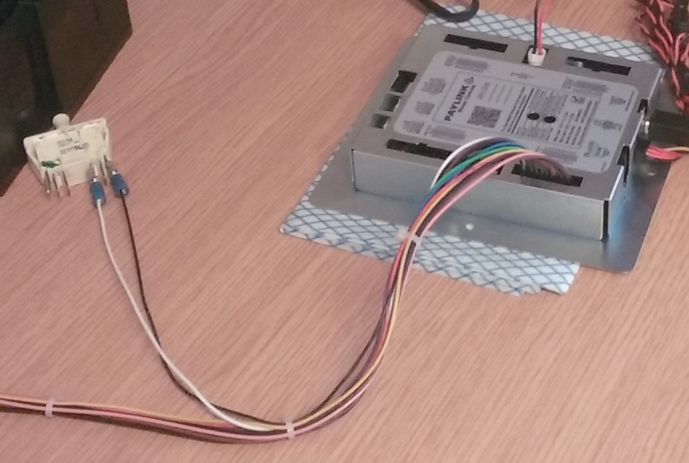

After that check the switch code in sample code.

## **2.3 SR5 Coin acceptor?**

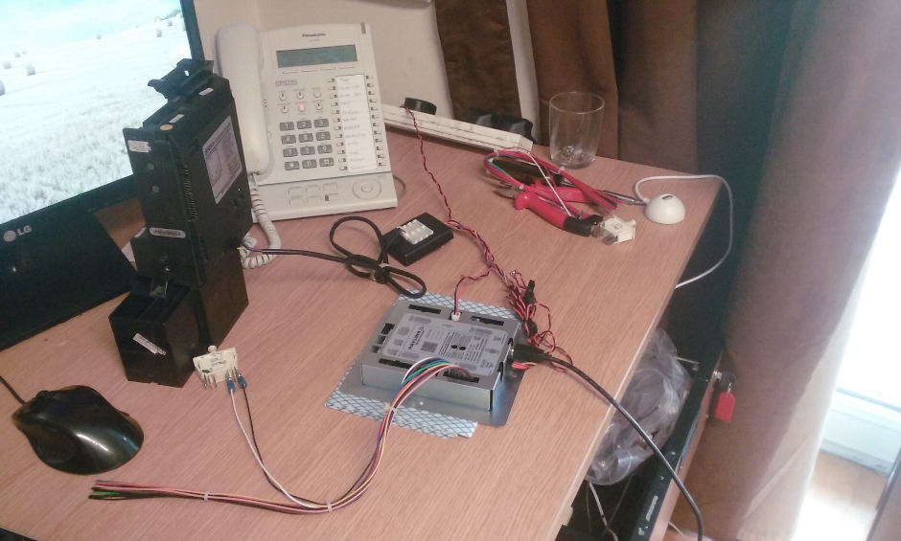

The Figure above is showing how to connect SR5 coin acceptor with PAYLINK. Note: The coin acceptor will accept default money but you can change it. See useful resources for software to change the currency.

## **2.4 How to Test everything is working correctly?**

Step1. Connect hardware and connect USB to computer. It will say Device is ready to use.

Step2. Run file from Paylink Distribution. It will give you an access message “16:02:53.190 Config: Paylink Checked OK against file "Standard.cfg"”

Step3. Run  from C:\PayLink Distribution\SDK. Go to acceptor and check that it list down your acceptors in the list and showing its Information with Status “OK”

# **3. Useful resources**

1. **Test Program**:  Paylink/SDK/Demo.exe

2.  **Download Coin Sets**: C:\PayLink Distribution\PayLink CoinNote Download\PayLinkDownloadWin.exe

3. **SR5 Money Files Set Examples**: C:\PayLink Distribution\PayLink CoinNote Download\SR5FileSet.exe

**Online Complete Documentations:**

<http://www.cranepi.com/en/products/view/147/tab:support#tabs>

<http://www.aardvark.eu.com/products/milan/downloads.htm>